Assignment 1

Group 2

1. The online voting system has been developed for the people to be able to vote online, whether it be a parliamentary or student union elections.
2. The election committee decides to create the election, initialize the name and checks if they meet the eligibility criteria for the specific election.
3. The candidate must register himself with the election committee and declare his eligibility and position: presidential or district.
4. The Election Commission generates a revised list of candidates up for voting based on the rules of the particular elections.
5. The election commission also decides on the duration and directions of the election.
6. The voters must go online and register himself for the election.
7. To register the voters must meet the eligibility criteria set up for him by Election Commission.
8. The voter can log in to his account and fetch all the details regarding the elections, i.e. the list of candidates, directions, duration of election and rounds of elections.
9. Finally, the votes are counted and the committee shall declare a winner. The declared results can be seen by the voter, election committee and candidate.

**Use Case Diagram For the Online Voting System:**

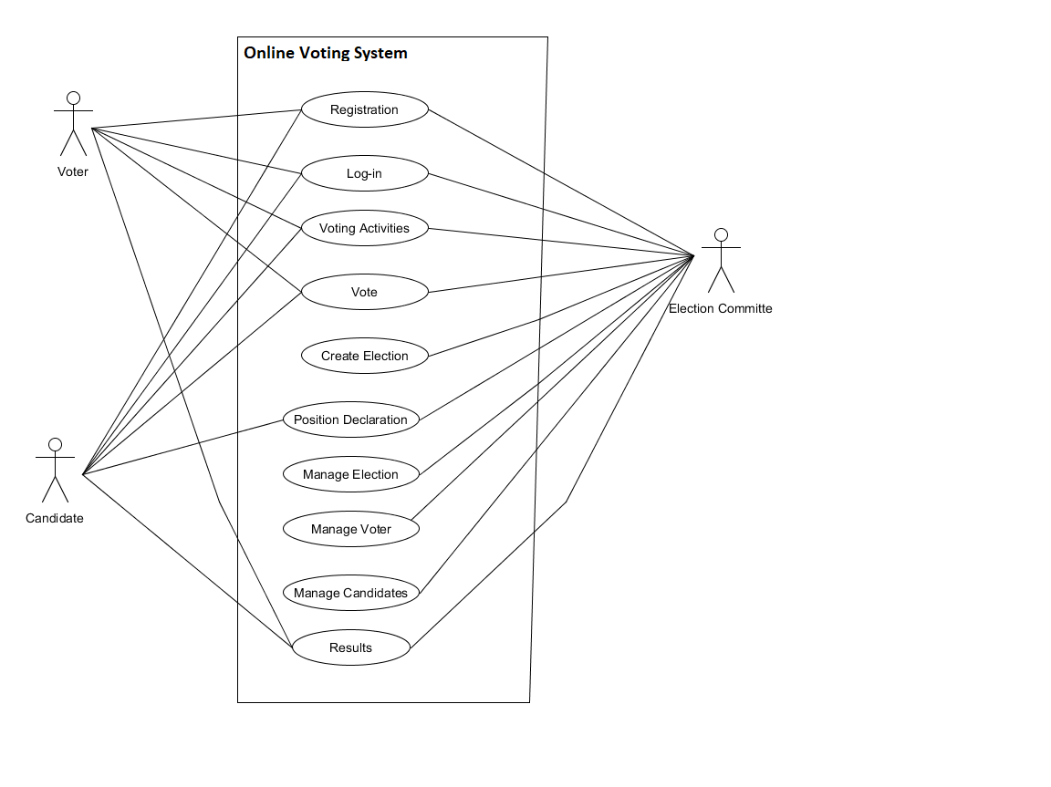

**Detailed description of three use cases:**

|  |  |
| --- | --- |
| **Name of Use Case:** | **Creating Elections** |
| Participating Actors | Election committee |
| Entry Conditions: | Following last year's minutes and the Committee decides about for holding elections |
| Flow of Events | 1.Once the date of elections fixed, the Candidates submit their nomination  2. The Candidate should update their details and check the voter list |
| Exit Conditions | The Election committees should have initial list of the candidates |
| Alternate flow | 1a. No candidate submit their nomination  1a1. The elections will be reschedule  2a. The minimum number of Candidates are not enrolled  2a1. The election will be rescheduled |

|  |  |
| --- | --- |
| **Name of Use Case:** | **Managing Elections** |
| Participating Actors | Election Committee |
| Entry Conditions: | The committee has the initial list of candidates |
| Flow of Events | 1.The Election committee sets up the rules required for the candidates to follow.  2.The Election committee sets up the rules for the voters.  3. The election committee processes the initial list of candidates based on rules.  4.The Election committee generates revised list of candidates. |
| Exit Conditions | The election committee should have a revised list of candidates |
| Alternate flow | 3a. Candidate withdraws from election.  3a1. The election committee reschedules the election.  4a. The minimum number of candidates aren’t processed.  4a1. The election committee reschedules the election. |

|  |  |
| --- | --- |
| **Name of Use Case:** | **Voting Activity** |
| **Participating Actors** | **Voter** |
| Entry Conditions: | Election Committee declares the activity. |
| Flow of Events | 1. The system prompts the voter to give the vote.  2. The voter chooses the candidate from candidate list.  3. The system sends a message to voter indicating that the vote is polled.  4. The server automatically deactivates the ballot number. |
| Exit Conditions | 1.Provides time frame for voting  2. Providing updation of voter’s information  3. The EC is asked for their(voters) correct information. |
| Alternate flow | 1a. The voter fails to select a candidate,then  1a1. The system will prompt with message “invalid vote” |

**Summary of Use cases:**

|  |  |
| --- | --- |
| Registration | The voters will provide their details. |
| Login | Once the user is registered, as per the user login authentication, users will be given specific rights to the system |
| Vote | Every registered voter should be able to vote. The system should accept only one vote per voter. |
| Manage Candidate | Candidates can be added, updated or removed.. It also lets the candidates view or update their details. |
| Position Declaration | Candidates apply for particular position (independent or party) and the election commission finalize the selective candidate. |
| Results | Once the voting process has been completed , tally all the casting vote and publish the results. |

**Domain Modelling for Online Voting System:**

